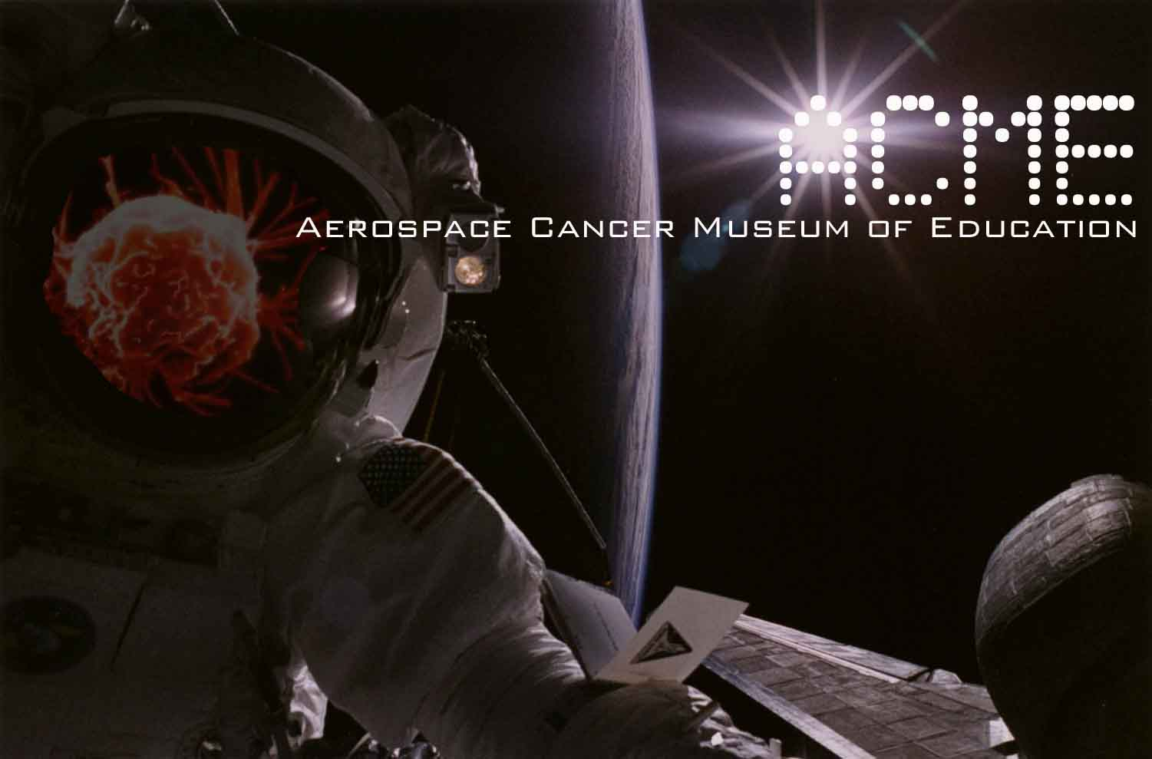

Stephanie Jennings 8/15/2008
NEPA Document Manager
U.S. Department of Energy (DOE, ETEC)
P.O. Box 10300
Canoga Park, California 91309
(Via U.S. Mail and E-mail)

Dear Ms. Jennings,

Enclosed please find my comments on the AREA IV Data Gap Analysis of the Santa Susana Field Laboratory (SSFL).

The 2005 Boeing Historical Site Assessment (HSA) needs to be redone entirely with oversight of Community Members. It is crucial that former employees be contacted for interviews as they are the key to finding pollution sources.

EVERY BUILDING in AREA IV, no matter how small, large or what was conducted in that facility HAS TO BE CONSIDERED AS RADIOLOGICAL!!!

We have made the mistake in the past of AREA IV building removals without oversight and the health of the surrounding neighborhoods have suffered.

With only a few buildings left, each one should be looked into, historically, with a fine-tooth comb. As you may know, there are buildings built on top of slabs of former Radiological buildings. So the history of each building is key in closure. For example, you know Building 4038 as your former ETEC Offices, yet before the addition of square footage, this building was used for Nuclear Research.

All of the former areas of operation including completed and “Clean Closed” areas of D & D need to bee looked into for Chemical and Radiological Soil contamination throughout AREA IV.

The Buffer Zones Southern and Northern need to be looked into as part of your Analysis as they received run-off from AREA IV. These areas need to be cleaned up to Senate Bill 990 Standards…It is the law. The groundwater can be linked to operational areas by “Fingerprinting” the sources and determining how far they have migrated, clean up until that point.

The AREA IV Borrow pit is a large concern as it was also used as a return pit or dumping ground. This area and all roads leading up to it need to be sampled and cleaned up to SB 990 Standards.

The Former Sodium Disposal Facility or AREA IV Burn Pit needs to be re-evaluated and cleaned up to SB 990 Standards.

The logbooks from all the AREA IV Facilities should be considered in this analysis as they are they key to the incidents of every building and storage area of AREA IV.

All of these are issue that need to be dealt with before and soil and/or Buildings in AREA IV is disturbed.

Thank you in advance for your time,

William Preston Bowling Founder/Director
ACME (Aerospace Cancer Museum of Education)
williamprestonbowling@yahoo.com
310.428.5085
http://www.ACMEla.org
23350 Lake Manor Drive
Chatsworth, California
91311

