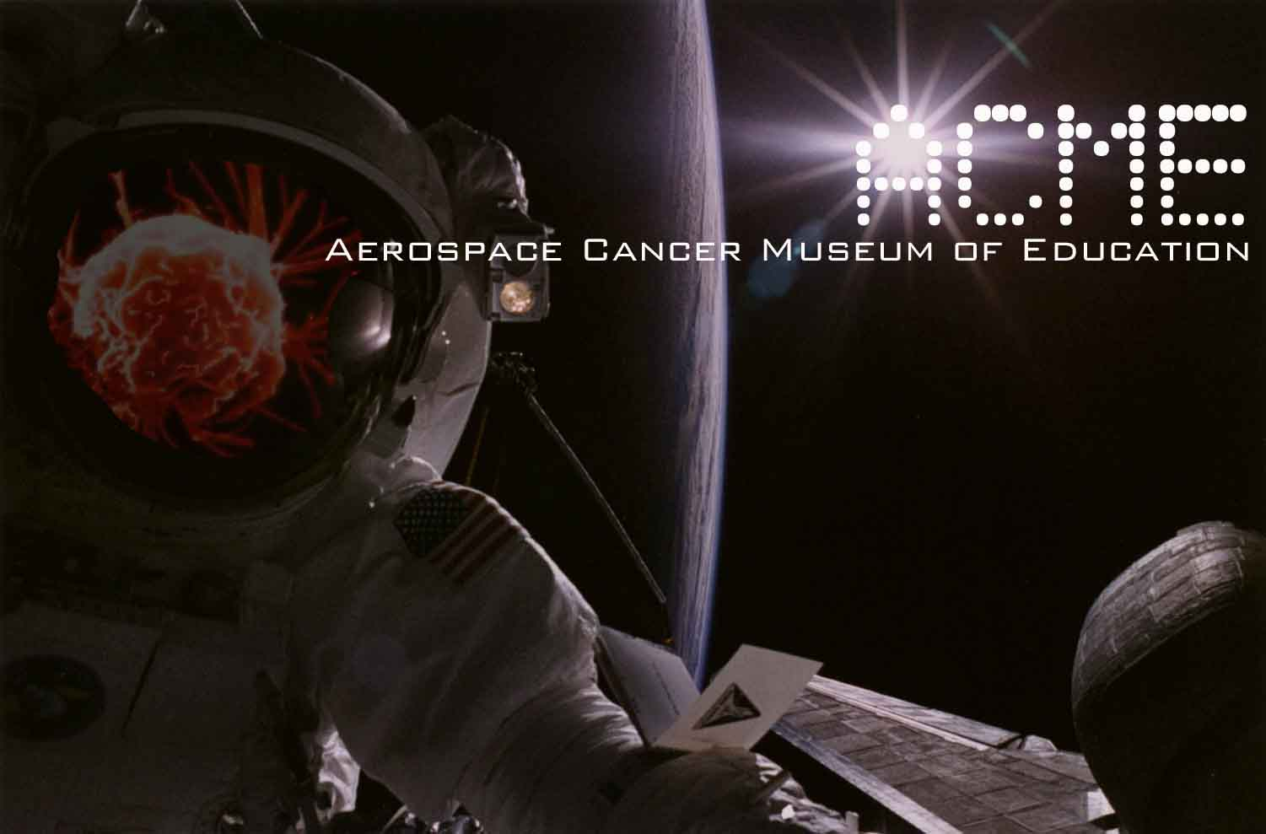

Tracy Egoscue 11/17/2008
David Bacharowski
California Regional Water Quality Control Board Los Angeles Region
320 West 4th Street, Suite 200
Los Angeles, CA 90013
cc. Susan Callery & Tom Seckington DTSC, Paul J. Davis City of Los Angeles Department of Recreation
Shelly Backlar Friends of the Los Angeles River, David Beckman NRDC, Christina Walsh Cleanuprocketdyne dot org

Dear Tracy,

Hope all is well. I have three things that I am hoping you could help me with.

- Any response in regarding the testing for TCE from the effluent of Chatsworth Train Tunnel No. 26 into Chatsworth Park South?
- Have you made arrangements for Christina Walsh and I to accompany the Waterboard on their upcoming tour of the Chatsworth Train Tunnel No. 26 drainage and interior of tunnel?
- Can you please send me an electronic copy of the October 21 of 2008 Letter from the Waterboard to Daniel Samorano, the Project Manager of the Raytheon Company regarding the Radioactivity on the proposed building site at Corporate Pointe in West Hills?

Thank you in advance for all your work on these issues. I look forward to your response.

Take care,

William Preston Bowling - Founder/Director
ACME (Aerospace Cancer Museum of Education)
williamprestonbowling@yahoo.com
310.428.5085
http://www.ACMEla.org
23350 Lake Manor Drive
Chatsworth, California
91311

