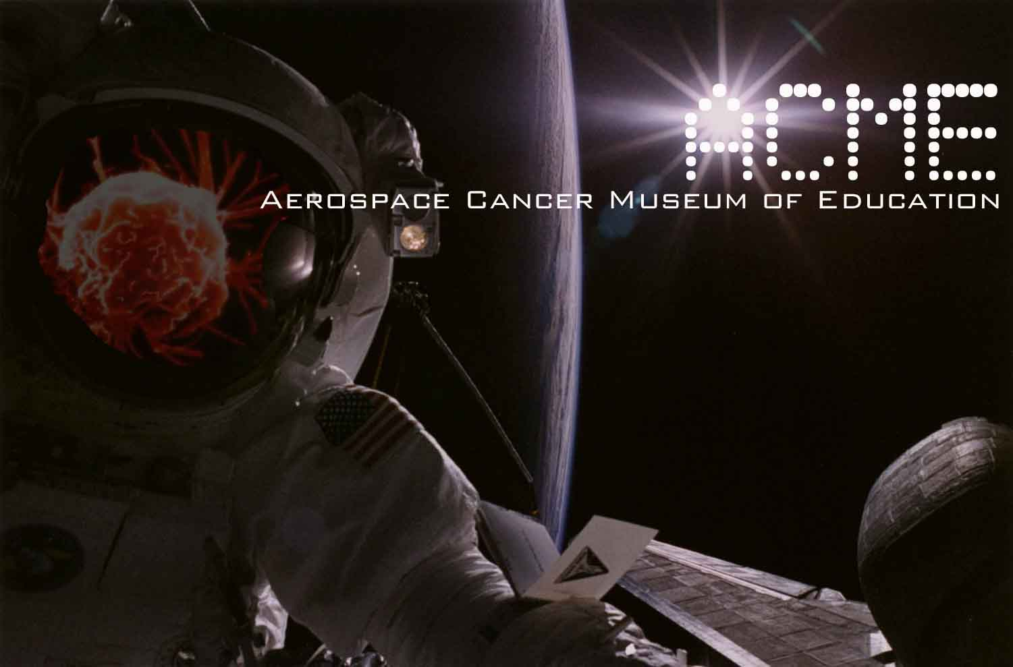

David Smith 10/17/2008
Chief Wetlands Regulatory Office (WTR-8)
EPA Region 9
75 Hawthorne Street
San Francisco, CA 94105
(415)-972-3464
(Via U.S. Mail and E-mail)

Dear Mr. Smith,

Thank you for holding up the standards of the Clean Water Act (CWA) and your delivery of the United States Army Corps of Engineers (USACE) contact information.

With a month in passing I have yet to hear from USACE despite several inquires. Have you reached out to Mr. David Castanon of the USACE?

I am still waiting for a response to my request that EPA facilitate a meeting between myself, my colleagues (including other groups such as Friends of the Los Angeles River (FoLAR) and the Natural Resources Defense Council (NRDC), USACE and EPA to fully discuss this issue.

The Aerospace Cancer Museum of Education (ACME) would be happy in providing our location.

I look forward to hearing from you.

William Preston Bowling - Founder/Director
ACME (Aerospace Cancer Museum of Education)
williamprestonbowling@yahoo.com
310.428.5085
http://www.ACMEla.org
23350 Lake Manor Drive
Chatsworth, California 91311

