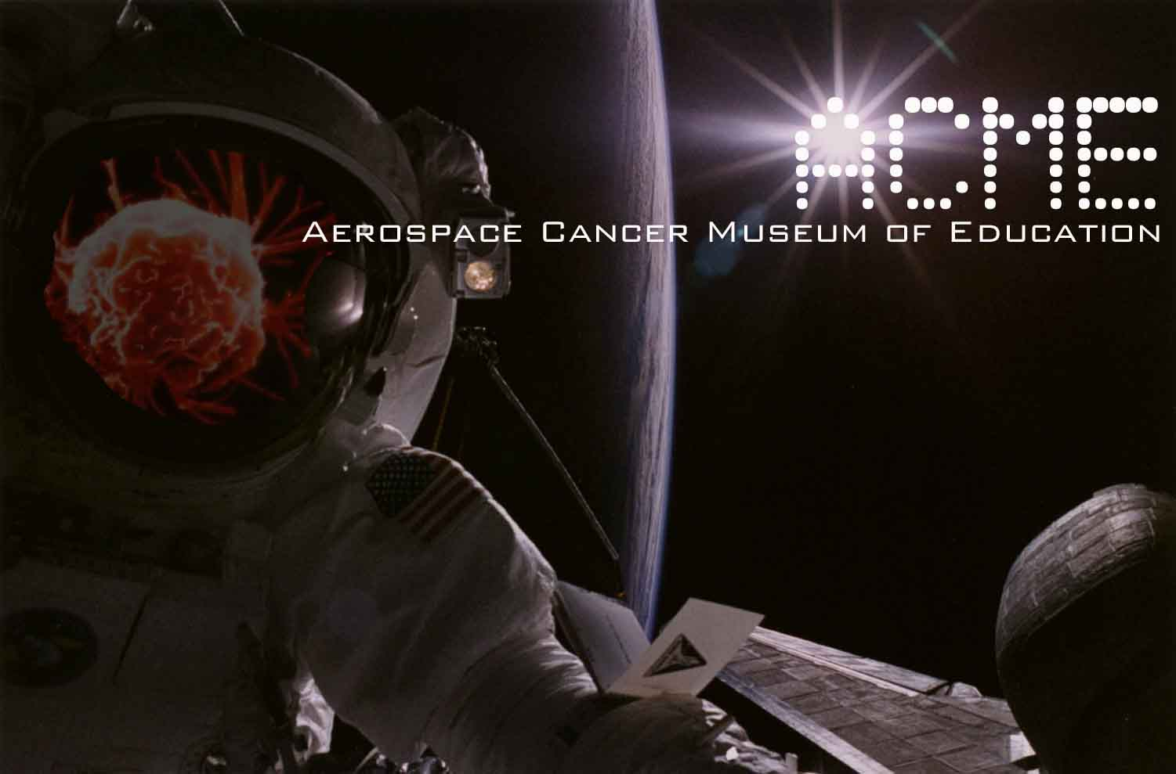

Tracy Egoscue 11/3/2008
David Bacharowski
California Regional Water Quality Control Board Los Angeles Region
320 West 4th Street, Suite 200
Los Angeles, CA 90013
(Via U.S. Mail and E-mail)

cc. Susan Callery & Tom Seckington DTSC
Paul J. Davis City of Los Angeles Department of Recreation
Shelly Backlar Friends of the Los Angeles River
David Beckman NRDC
Christina Walsh Cleanuprocketdyne dot org

In addition to my October 31st, 2008 letter I would like to add that at 5:17pm on Friday, October 31st, 2008 I received an e-mail from Merrilee Fellows the Manager for Community Involvement for Environmental Remediation of the National Aeronautics and Space Administration (NASA). It contained an updated Trichloroethylene (TCE) fact sheets in reference to the Santa Susana Field Laboratory (SSFL). Click on the link below to view these documents…

http://www.acmela.org/nasa.html

I am hoping these documents may help in your looking into our concerns.

TCE is a major problem at the SSFL and The Boeing Company have confirmed that the TCE Plume is migrating offsite towards the Santa Monica Mountains Conservancy parkland at Sage Ranch.

It is the conclusion of ACME that the over 70 sump pumps inside Chatsworth Train Tunnel No. 26 is drawing the contamination away from the SSFL.

Merrilee Fellows from NASA’s e-mail reads…

In August I distributed two fact sheets. (Note that some new addressees, above, have been added since that time. Please forward this to others who may be interested; I'm still trying to get a fuller email distribution list.)
Marie Mason's (Member of the Santa Susana Field Lab Workgroup) careful reading prompted a comment that we should provide more information clarifying that groundwater treatment had ceased. We have revised both fact sheets to address that suggestion, and now include the specific times that each water treatment system was stopped (pertaining to the NASA site). It is the last paragraph in each fact sheet, and now reads:
"Beginning in 1984, a pump-and-treat system was used to clean groundwater in NASA's Area II. The treatment for the Alfa area has been inactive since 2001 and for the Bravo area since 2002. The Delta treatment plant became inactive in August 2007. A new centralized treatment system is scheduled to begin operating in 2009."
<<SSFL NASA Overview Oct 2008.pdf>> <<SSFL NASA TCE Use Oct 2008.pdf>>
Merrilee Fellows NASA Manager for Community Involvement for Environmental Remediation 180-801 4800 Oak Grove Drive Pasadena, CA 91109 818.393.0754 mfellows@nasa.gov

I am cc’ing Ms. Fellows, alerting her to our concerns.

This is an urgent matter and should be treated that way. I look forward to your immediate action on this issue.

William Preston Bowling - Founder/Director
ACME (Aerospace Cancer Museum of Education)
williamprestonbowling@yahoo.com
310.428.5085
http://www.ACMEla.org
23350 Lake Manor Drive
Chatsworth, California
91311

